ECE 3300L

Lab 8

Instructor: Dr. Mohamed El-Hadedy

Group A

Joseph Popoviciu & Sami Elias

Objective:

Have two up/down counters that will be inputted into two separate barrel shifters. From there, the values will be shifted or rotated, depending on what we select. After that, the values will be thrown in an ALU and have an 8 bit output. Since we do not have enough switches to operate the input, barrel shifter, ALU, and clock manager, we designed a module to allow us to use a button to select between the barrel shifter and the ALU operation. The button will change the state we are in. We assigned the LED farthest to the left to the function of the button. When the button is pressed, it will turn the LED on which will allow us to control the ALU operation using the two most significant switches. If we press the button again, the LED will turn off and we will be able to control the barrel shifter without changing what the barrel shifter does.

Results:

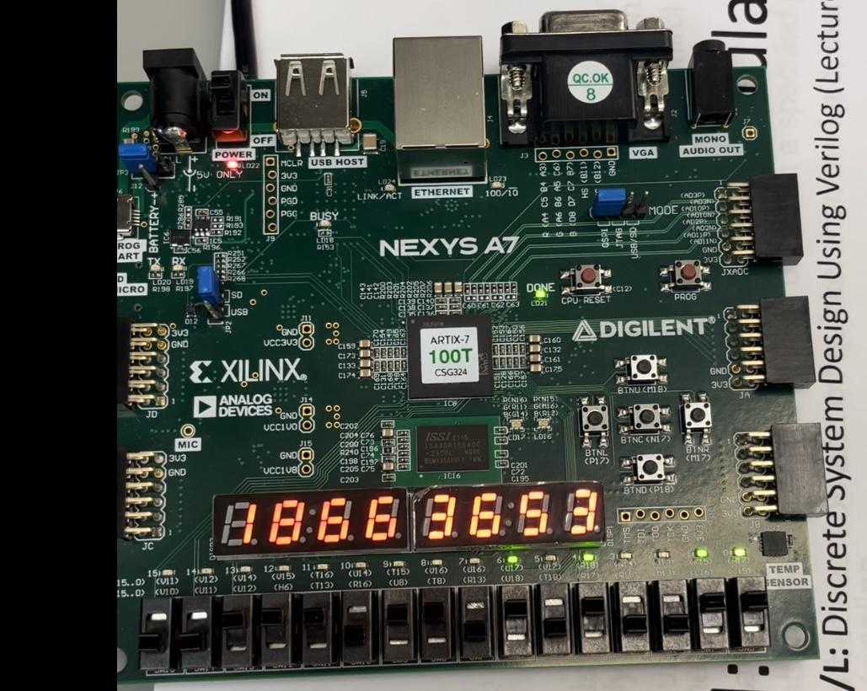

The image above shows the board running. The two switches to the left (15 and 14) are what control the ALU and the barrel shifter. When switches 14 and 15 are high and the barrel shifter is selected, it will shift instead of rotate. When we switch to the other function, the function that was previously selected will stay the same. For example, if we are adding and we decide to switch to the barrel shifter, the ALU operation will stay in addition. The two switches next to those (13 and 12) control the up down counters. The four switches next to those (11 through 8) control the clock divider. The rest of them control the two input values. Since they are two four bit numbers, four switches will be controlling each input. The rightmost black button (M17) is what controls if we are controlling the ALU or the barrel shifter. We also have buttons to input the digits into the counters (M18 and P17). P17 will upload the second digit into the up/down counter, and M18 will upload the first digit.

Schematic:

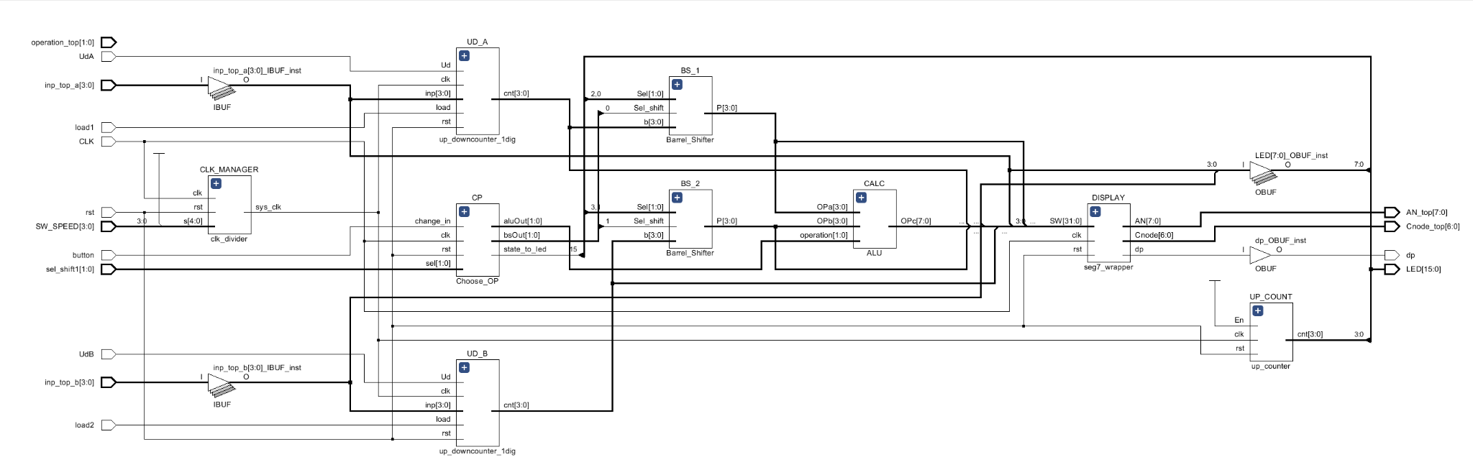

Implementation:

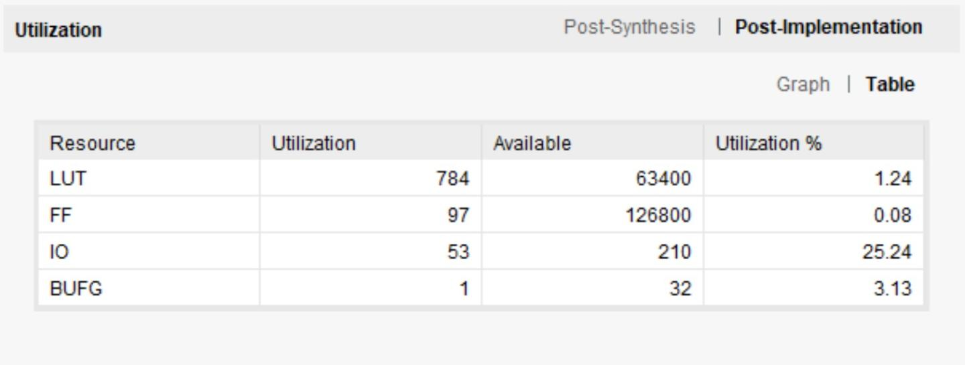

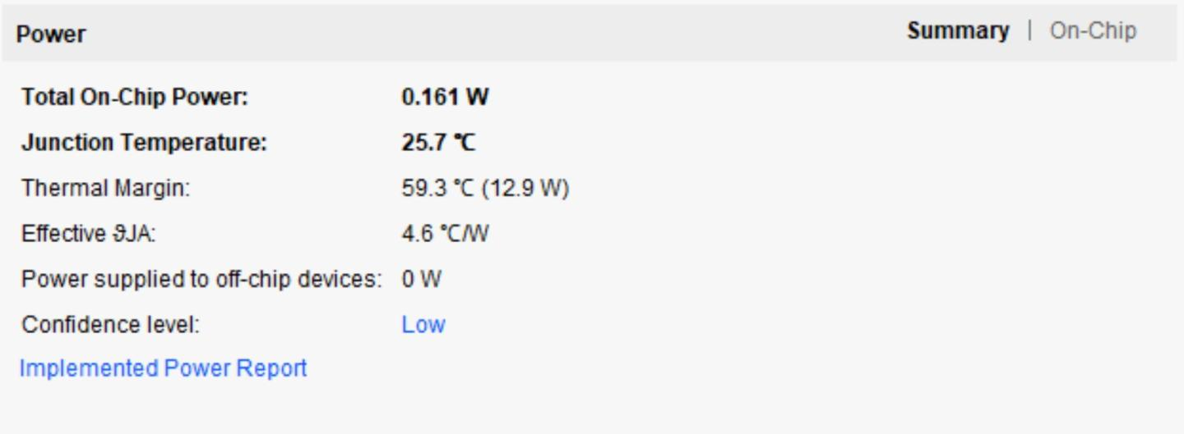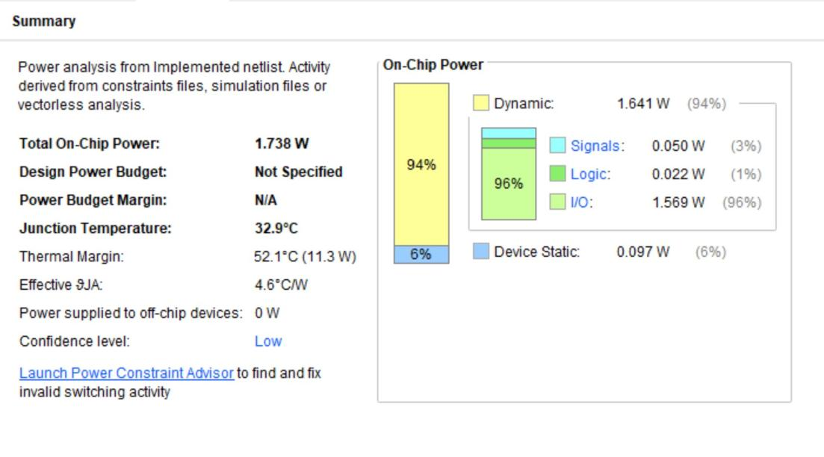

Conclusion:

We were able to use previous modules we built such as the ALU, clock manager, counters. We also implemented a new module called the barrel shifter. Another new module was used to implement a button to switch between functions. We put all those together to make something similar to a random number generator. The most difficult portion of this lab was understanding how to implement so many functions and assign wires to multiple locations.